Mohamed Walid Shaker

How To Use Task Scheduler in Windows

* Task Scheduler is a built-in utility that allows you to schedule and automate tasks or programs to run at specific times or under certain conditions. It provides a graphical user interface for managing scheduled tasks .
* 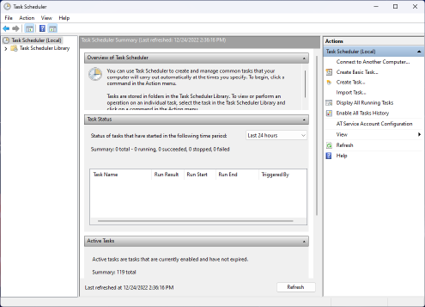

On a Windows PC, Task Scheduler is a built-in utility that allows you to schedule and automate tasks or programs to run at specific times or under certain conditions. It provides a graphical user interface for managing scheduled tasks. You can access Task Scheduler through the Windows Control Panel or by searching for it in the Start menu.

Here's how you can access Task Scheduler and create scheduled tasks:

Accessing Task Scheduler:

Press Win + S to open the Windows Search bar.

Type "Task Scheduler" and press Enter.

Creating a Scheduled Task:

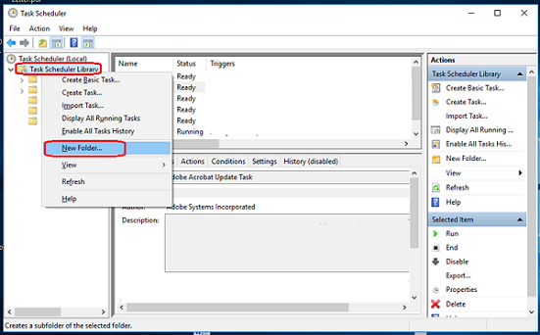

In Task Scheduler, you can create a new task by right-clicking on the "Task Scheduler Library" in the left pane and selecting "Create Basic Task" or "Create Task" for more advanced configurations.

Follow the wizard to set up your task. You'll need to specify a name, description, when and how often the task should run, and what action or program it should execute.

Configuring Task Triggers:

You can schedule tasks to run daily, weekly, monthly, or at specific times.

You can also set triggers based on events, such as system startup, user logon, or when a specific event occurs in the system logs.

Configuring Task Actions:

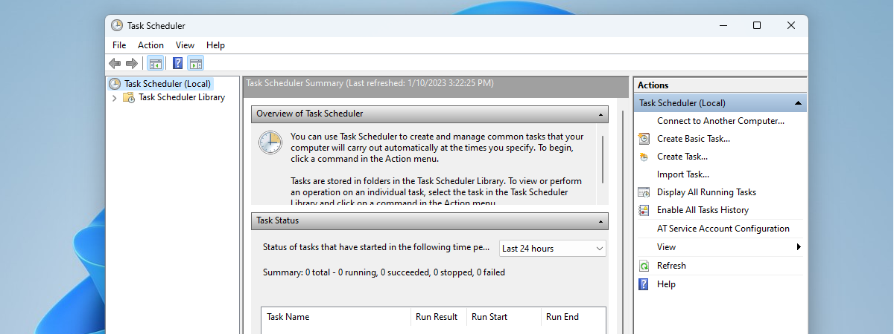

You specify what action the task should perform. This could be running a program, sending an email, or displaying a message.

Setting Conditions:

You can set conditions for the task to run, such as only when the computer is idle or only if the computer is on AC power.

Configuring Settings:

You can set various settings, such as whether the task should run with the highest privileges, whether it should be hidden, and more.

Review and Finish:

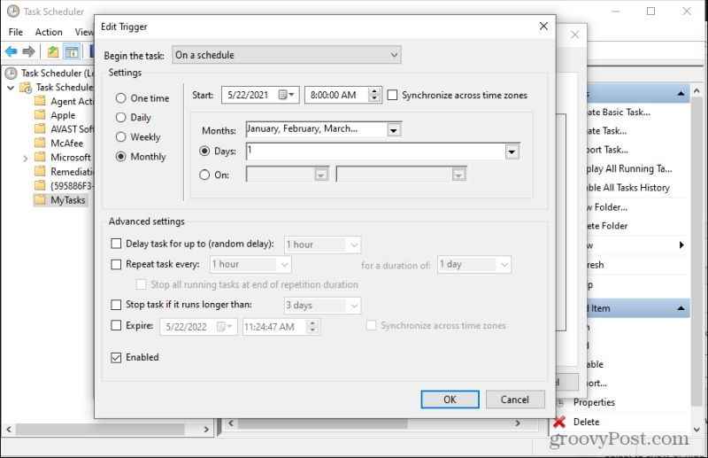

After configuring all the details, review your settings and click "Finish" to create the scheduled task.

Once you've created a scheduled task, it will be listed in the Task Scheduler Library. You can edit, disable, or delete tasks as needed.

Task Scheduler is a powerful tool that can automate a wide range of tasks on your PC, from running maintenance scripts to launching applications or performing backups at specified times. It's especially useful for streamlining routine computer management and maintenance tasks.